 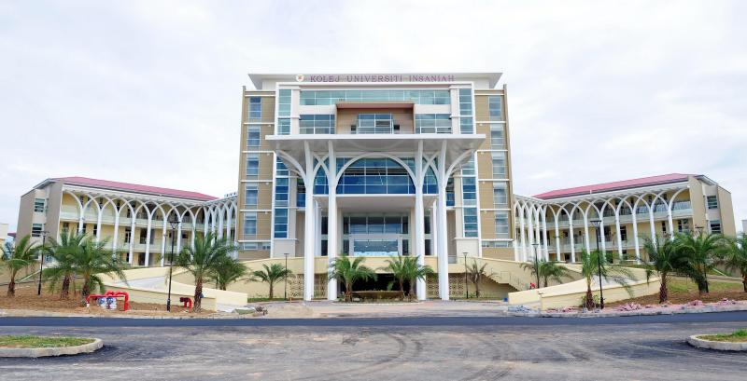

The research was Funded by

UNIVERSITY ISLAM ANTARABANGSA SULTAN ABDUL HALIM MU’ADZAM SHAH

penyelidikan ini dibiaya oleh

UNIVERSITY ISLAM ANTARABANGSA SULTAN ABDUL HALIM MU’ADZAM SHAH

Cover Buku

nama ketua penyelidik & penyelidik BERSAMA

The research was Funded by

UNIVERSITY ISLAM ANTARABANGSA SULTAN ABDUL HALIM MU’ADZAM SHAH

Tajuk Penyelidikan

RESEARCHERS  
LEADER:

------------------------------

MEMBERS:

_________________________________

__________________________________

_________________________________

Funded by:

Sultan Abdul Halim Mu’adzam Shah

International Islamic University (UniSHAMS),

in Fulfilment of the Requirement for the University Research Grants

Dibiaya oleh:

Universiti Islam Antarabangsa

Sultan Abdul Halim Mu’adzam Shah (UniSHAMS),

**dalam Memenuhi Keperluan Geran Penyelidikan Universiti**

The Influence Of Dividend In Sustaining Corporate Governance And Corporate Social Responsibility On Shariah Compliance Companies Performance

Oleh : Dr. Rahayati Ahmad, Farah Nadirah Addul Manan, Nurul Shahariza Abu Hasan,Dr. Syahiza Arsad and Shaamila Shahabuddin

Cetakan Pertama 2020

Hak cipta terpelihara. Sebarang bahagian dalam buku ini tidak boleh diterbitkan semula, disimpan dalam cara yang boleh digunakan semula, ataupun dipindahkan dengan sebarang bentuk ayat dengan sebarang cara, baik dengan cara elektronik, penggambaran semula dan sebagainya tanpa mendapat izin daripada pemilik hak cipta terlebih dahulu.

Diterbitkan oleh:

UniSHAMS SDN. BHD

Universiti Islam Antarabangsa

Sultan Abdul Halim Mu’adzam Shah (UniSHAMS),

09300 Kuala Ketil, Kedah Darul Aman, Malaysia

Cetakan oleh:

ASA MESRA PRINTER

No 9, Lot 33 Bandar Darul Aman,

06000 Jitra

Kedah Darul Aman, Malaysia

Pihak Untuk Dihubungi:

Pusat Pengurusan Penyelidikan

Tel.: +604-415 5087

Fax.: +604-415 5050

Email: rmc@unishams.edu.my

ISBN:

Tarikh: November 2020

ACKNOWLEDGEMENT

ABSTRACT

THE INFLUENCE OF DIVIDEND IN SUSTAINING CORPORATE GOVERNANCE AND CORPORATE SOCIAL RESPONSIBILITY ON SHARIAH COMPLIANCE COMPANIES PERFORMANCE

Rahayati Ahmad1, Farah Nadirah Abdul Manan2, Nurul Shahariza Abu Hasan 3, Syahiza Arsad4 Shaamila Shahabuddin5

Kuliyyah Muamalat & Sains Pengurusan 1& 4

International Islamic University Sultan Abdul Halim Mu’adzam Shah

Kuala Ketil, Kedah.

Pusat Pengajian & Penyelidikan Kewangan Islam 2&3

International Islamic University Sultan Abdul Halim Mu’adzam Shah

Kuala Ketil, Kedah

Centre for Counseling and Psychological Services, Sultan Abdul Halim Mu’adzam Shah International Islamic University (UniSHAMS), Malaysia5

__________________________________________________________________________________________________________________________________________________________________________________________________________________________________________________________________________________________________________________________________________________________________________________________________________________________________________________________________

Keywords: corporate governance; corporate social responsibility; dividend; performance,

TABLE OF CONTENTS

DECLARATION Error! Bookmark not defined.

ACKNOWLEDGEMENT 4

ABSTRACT 5

TABLE OF CONTENTS 6

LIST OF TABLES 7

LIST OF FIGURES 8

1.0 INTRODUCTION 9

1.1 Performance of Syariah Compliance Companies 9

1.2 Corporate Governance **Error! Bookmark not defined.**

1.2.1 The Stewardship and Agency Theory **Error! Bookmark not defined.**

1.3 Corporate Social Responsibilities **Error! Bookmark not defined.**

1.4 Dividend as Motivational Tool **Error! Bookmark not defined.**

2.0 LITERATURE REVIEW 9

2.1 Corporate Governance and Performance **Error! Bookmark not defined.**

2.2 Corporate Social Responsibility and Performance **Error! Bookmark not defined.**

2.3 Dividend as the Moderator **Error! Bookmark not defined.**

2.4 Control Variables **Error! Bookmark not defined.**

3.0 METHODOLOGY 9

3.1 Dependent Variables **Error! Bookmark not defined.**

3.2 Independent Variables **Error! Bookmark not defined.**

3.3 Development of Corporate Governance Index’s **Error! Bookmark not defined.**

3.4 Development of Corporate Social Responsibilities Index’s **Error! Bookmark not defined.**

3.5 Data Analysis **Error! Bookmark not defined.**

4.0 FINDINGS 10

4.1 Classic assumption test **Error! Bookmark not defined.**

4.1.1 Dependent Variables-Performance (CGPA) **Error! Bookmark not defined.**

4.1.2 Independent Variables-Employability **Error! Bookmark not defined.**

1.1 CONCLUSION 10

REFERENCES 10

LIST OF TABLES

Table 3.1 Population And Sampling of the Main Board of Bursa Malaysia **Error! Bookmark not defined.**

Table 3.3 Total items in Corporate Social Responsibility (CSR) Disclosure Index **Error! Bookmark not defined.**

Table 3.4 Summary of the variables **Error! Bookmark not defined.**

Table 4.1 Descriptive Analysis 10

Table 4.2 Pearson Correlation Analysis **Error! Bookmark not defined.**

Table 4.3 Model Summary of Hierarchical Multiple Regression **Error! Bookmark not defined.**

Table 4.4 ANOVA Result of the Three Model of Hierarchical Multiple Regression **Error! Bookmark not defined.**

Table 4.5 Hierarchical Multiple Regression Result on the Influence of Dividend on the Relationship between Corporate Governance (CGI) and Corporate Social Responsibility on Performance (Tobin’s Q) **Error! Bookmark not defined.**

LIST OF FIGURES

Figure 1 The number of Public Listed Companies In Bursa Malaysia Froam 2009-2016 **Error! Bookmark not defined.**

Figure 2 Trend of Malaysian Stock Market Returns from 2009 until 2013 **Error! Bookmark not defined.**

# Introduction

## Performance of Syariah Compliance Companies

# Background of Study

# Research Objectives

# Literature Review

# The Conceptual Framework

Based on the previous study a graphical representation of the conceptual framework representing the overall picture of this study.

**CONTROL VARIABLES**

LEVERAGE

SIZE

TYPE OF INDUSTRIES

**DEPENDENT VARIABLES**

PERFORMANCE (TOBIN’S Q)

**INDEPENDENT VARIABLES**

CORPORATE GOVERNANCE INDEX (CGI)

CORPORATE SOCIAL RESPONSIBILITIES (CSRI)

**H1& H2**

**H3**

**H4 & H5**

**MODERATING VARIABLES**

DIVIDEND PAYOUT

Figure ‎5.1 Conceptual Model of the Study

# Methodology

# FINDINGS

Table . Descriptive Analysis

|  |  |  |  |  |  |  |
| --- | --- | --- | --- | --- | --- | --- |
|  | **Minimum** | **Maximum** | **Mean** | **Std. Deviation** | **Skewness** | **Kurtosis** |
| TOBIN Q | 0.030 | 1.010 | 0.408 | 0.199 | 0.257 | -0.301 |
| CGI | 0.255 | 0.709 | 0.516 | 0.105 | -0.397 | -0.196 |
| CSRI | 0.021 | 0.701 | 0.413 | 0.215 | -0.507 | -1.163 |
| DIV | 0.000 | 98.240 | 28.885 | 25.264 | 0.655 | -0.257 |
| LEV | 0.000 | 64.270 | 17.970 | 17.834 | 0.673 | -0.632 |
| SIZE | 4.600 | 7.610 | 5.583 | 0.759 | 1.043 | 0.155 |
| TYPE | 1.000 | 3.000 | 1.469 | 0.680 | 1.135 | 0.011 |

*N=209 Malaysian listed companies*

# CONCLUSION

# REFERENCES

# Appendixes

Appendix .

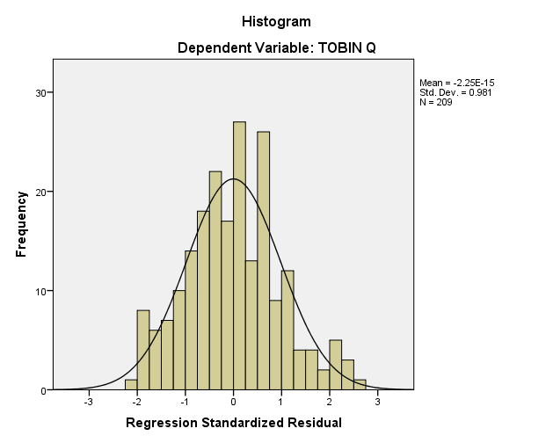

**RESEARCH OUTPUT**



FINAL REPORT UNIVERSITY SHORT TERM GRANTS

SULTAN ABDUL HALIM MU’ADZAM SHAH INTERNATIONAL ISLAMIC UNIVERSITY (UniSHAMS)

RMC09

RESEARCH MANAGEMENT CENTRE

**BORANG LAPORAN AKHIR PENYELIDIKAN PENYELIDIKAN UNIVERSITI / FUNDAMENTAL (FRGS) /SCIENCEFUND / IRPA / OTHERS**

RESEARCH FINAL REPORT

RESEARCH UNIVERSITI / FUNDAMENTAL RESEARCH GRANT SCHEME (FRGS) /

SCIENCEFUND / IRPA / OTHERS……………………

1. **BUTIRAN PROJEK/ Tarikh Laporan/**

*PROJECT DESCRIPTION Date of the Report : 20 DEC 2020*

* 1. **No Pendaftaran/**

|  |  |  |
| --- | --- | --- |
|  |  |  |

|  |  |  |  |
| --- | --- | --- | --- |
|  |  | **-** |  |

|  |  |  |  |
| --- | --- | --- | --- |
|  |  |  |  |

*Account No***: -**

* 1. **Tajuk Projek/**

*Project Title***: THE INFLUENCE OF DIVIDEND IN SUSTAINING CORPORATE GOVERNANCE AND CORPORATE**

**SOCIAL RESPONSIBILITY ON SHARIAH COMPLIANCE COMPANIES**

* 1. **Nama Ketua Projek**/

*Project Leader***:. DR RAHAYATI AHMAD.**

**4 .Penyelidik Bersama/**

*Co-researchers*: **DR SYAHIZA ARSAD, FARAH NADIRAH ABDUL MANAN,NURUL SHAHARIZA ABU**

**HASSAN**

1. **Tarikh Mula Penyelidikan/**

*Starting date of the project***:**

0 1

|  |  |  |  |
| --- | --- | --- | --- |
| 2 | 0 | 1 | 9 |

*(***Bulan***/Month) (***Tahun***/Years)*

1. **Tempoh Projek/**

*Duration of the project 1 2* **Bulan**/*Month(s)*

1. **Tempoh Projek Dilanjutkan/** a.

*Duration of the project extend*

**dalam tempoh asal yang dicadangkan; atau**

*within the period that originally proposed; or*

b. **dilanjutkan melebihi tempoh yang dicadangkan**

*extended beyond the proposed period*

1. **a. Objektif projek asal [Seperti yang dijelaskan dalam borang permohonan]**

*Original project objectives [As described in the application form]*

The purposes of carrying out this research were:

1. To examine the levels of the Corporate Governance and Corporate Social Responsibilities of Malaysian

Syariah Compliance Companies for the year ended 2012

1. To investigate the relationships between the Board Governance and Corporate Social responsibilities

toward performance of the Malaysian Syariah Compliance Companies for the years ended 2012.

1. To examine the influence of dividend as a moderating variable on the relationships between the Board Governance and Corporate Social responsibilities toward performance of the Malaysian Syariah

Compliance Companies for the years ended 2012.



BiographY of researchers

Dr.syahiza arsad (team members)

Syahiza Arsad obtained her PhD of Accounting from University Technology MARA, Shah Alam, Selangor and Master of Business Administration (MBA–Accounting) from University Utara Malaysia (UUM) Kedah. Currently, she is working as a lecturer and held a position as Head of Strategic Planning & Industry Unit at University Islam Antarabangsa Sultan Abdul Halim Mu’azam Shah, Kuala Ketil,

Picture leader

 biography leaders

Picture Members

biography members

